LINUX – PRACTICE DATE : 31/01/2017

USER ACCOUNTS

To create user

*adduser username*

To assign password to user

*Passwd username*

**

**

How to convert normal user to sudouser

*vim /etc/sudoers or visudo*

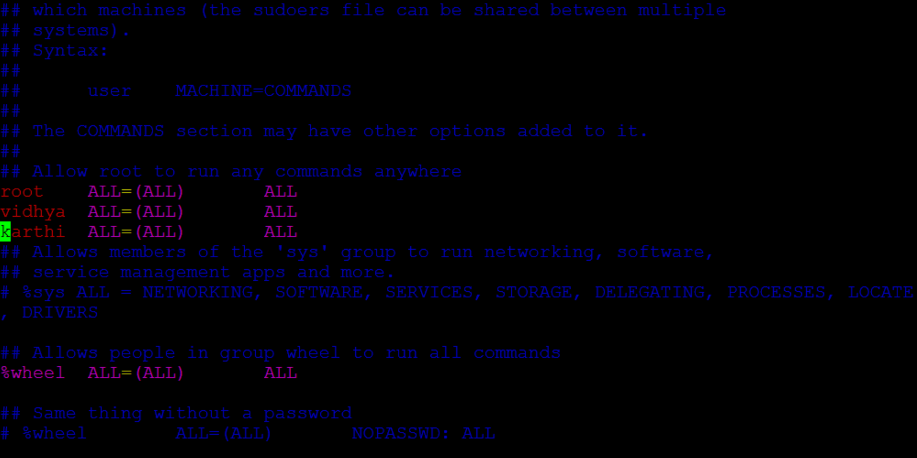

How to delete user and add same user

*userdel username and rm –rf username*

To delete that users complete file

1. *cd var/spool*
2. *cd mail*
3. *userdel username and rm –rf username*
4. *useradd sameusername*



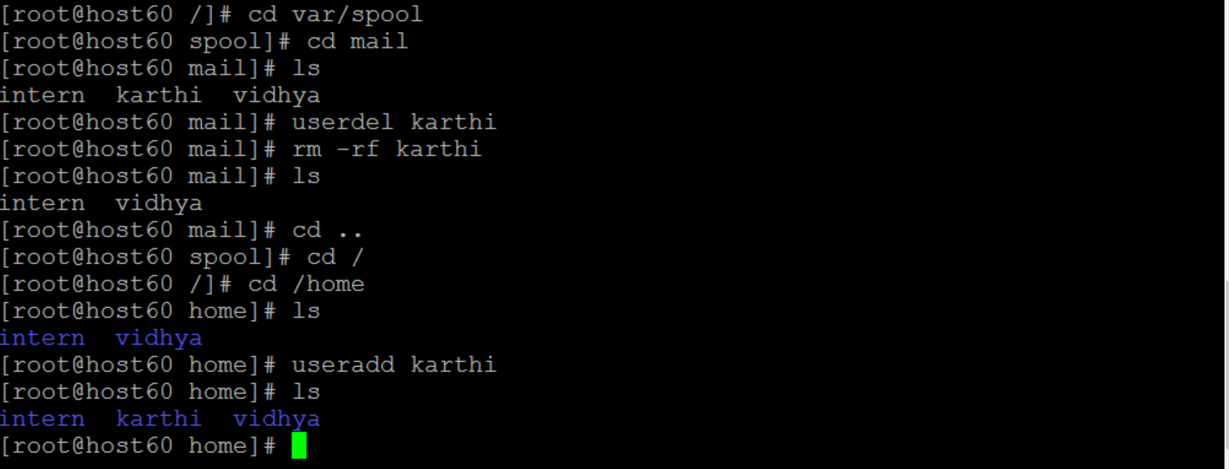

How to create group and add user

*groupadd groupname*

*usermod -G groupname username*

check the user who are in that group

*lid –g hpe ->* display who are the user in that group

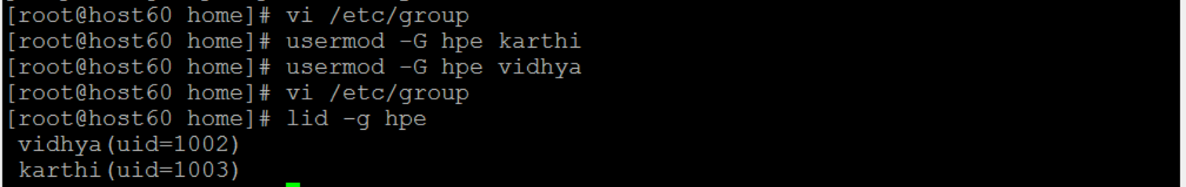

How to delete user from the group

*gpasswd -d username groupname*

Date : 30/01/2017

**SYSTEM MONITOR RESOURCES**

* Process
* Priority
* Signal Kill

Process:

*ps ->* getting info about running system

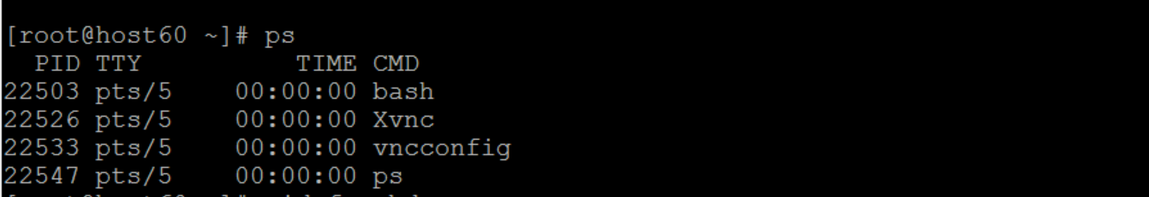

*pidof ->*  shows the pid of particular service

**

*top ->* dynamic view of the process status

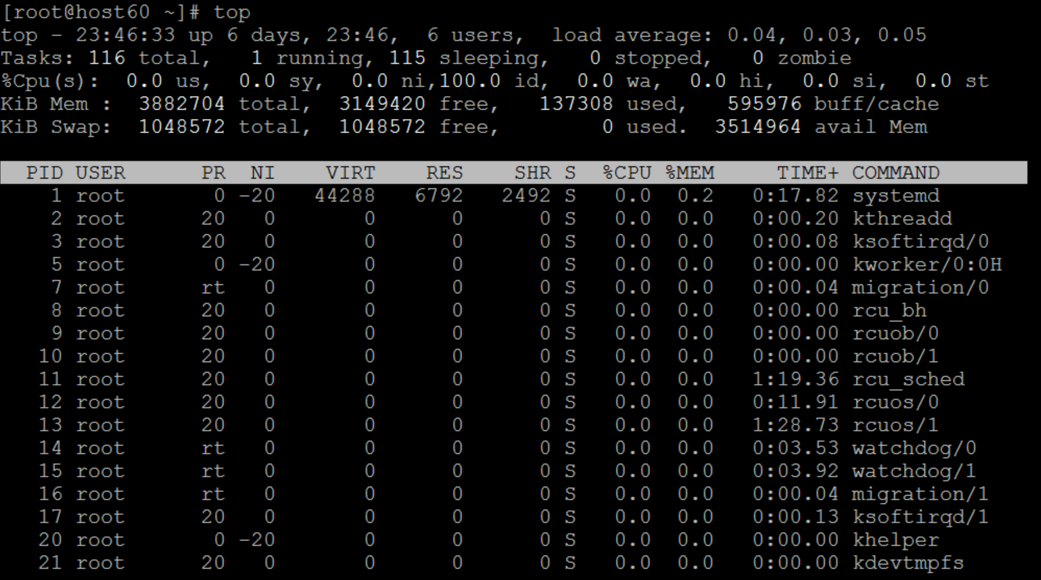

*d ->* delay to refresh timing (3.0 to 5.0)

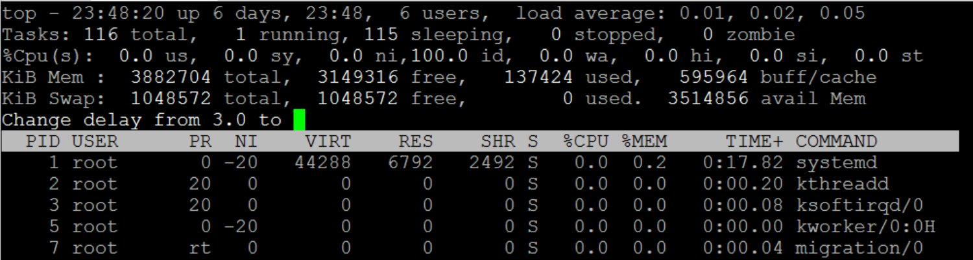

*shift + p ->* sort the current process which is running currently

*shift +m ->* sort the memory process which is running currently

*r ->* renice the value range from -20 to +20

*1 ->* how many cpu’s are using currently (number 1)

How to terminate the process:

*kill ->* kill the process (terminate/stop)

*9 or SIGKILL*

*15 or SIGTERM*

*kill -9 pid or kill SIGKILL pid ->* To kill the process of particular pid

*pkill -9 sshd* (sshd – process name) -> kill the full process

*killall ->* kill all the process

SYSTEM STATISTICS

Date: 25/01/2017

**How to check machine configuration / details**

*man uname*

*info uname*

*uname*

*uname -a*

*cat /etc/redhat-release*

*free -m*

*df -h*

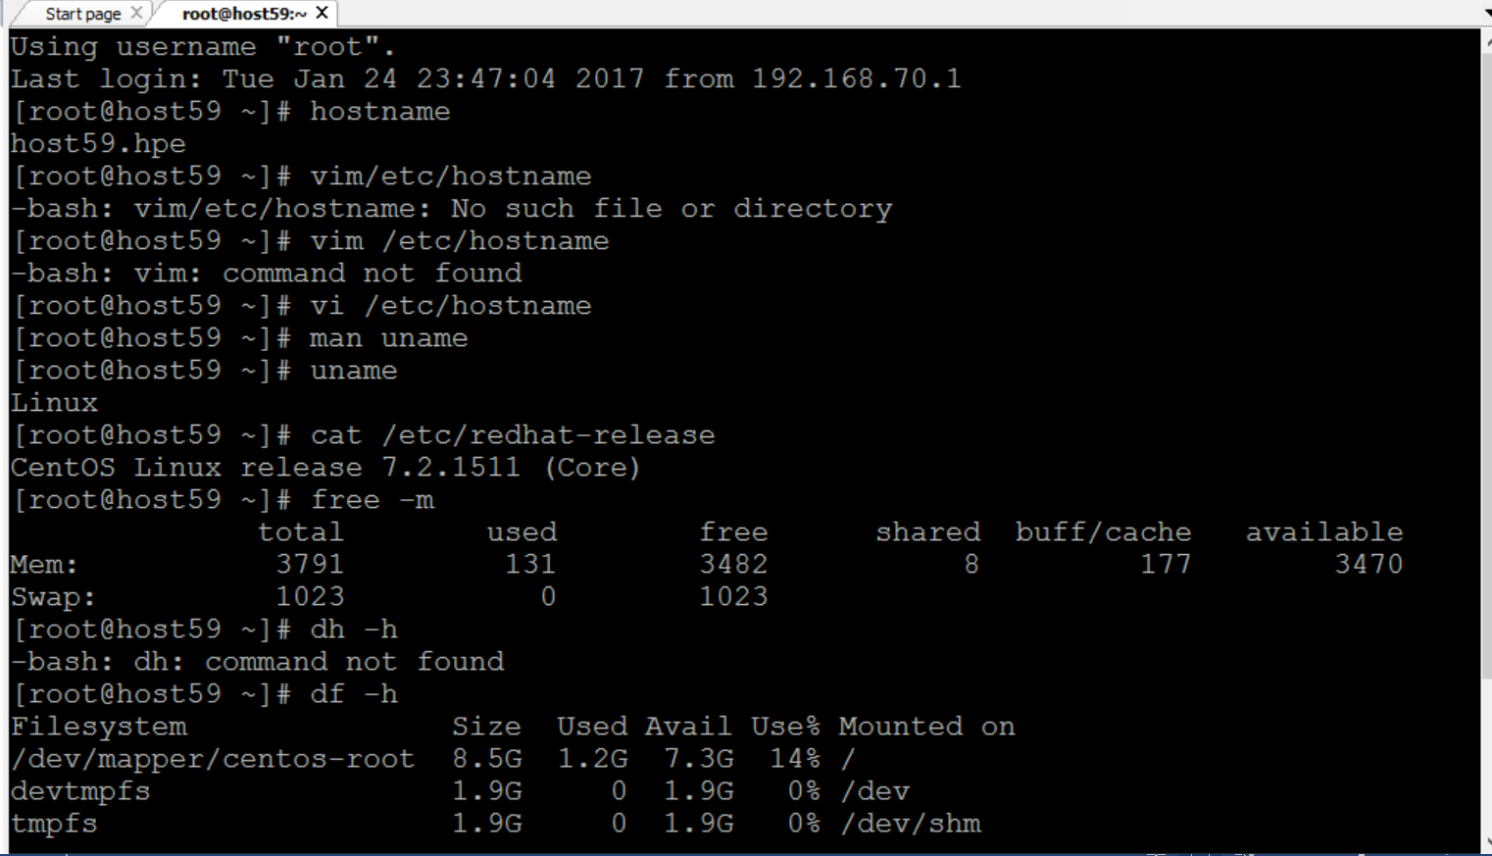

*du -h*

**

*Sestatus*

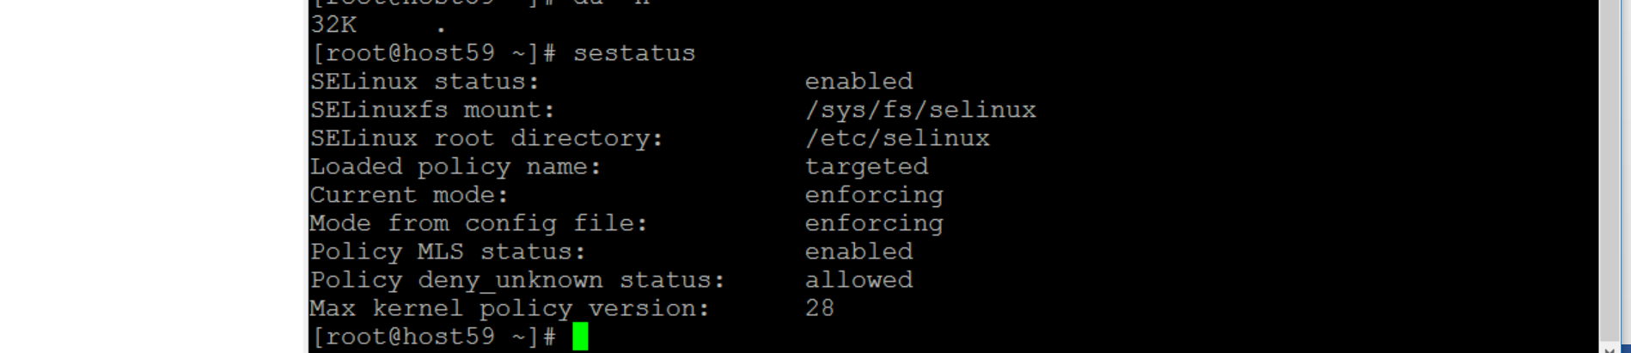

*selinux*

*cd /etc/selinux*

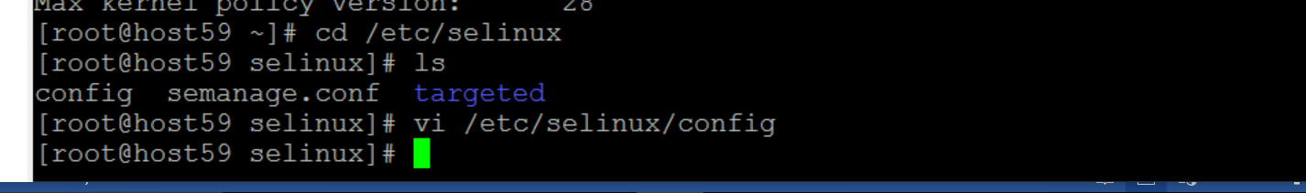

*getenforce*

*setenforce*

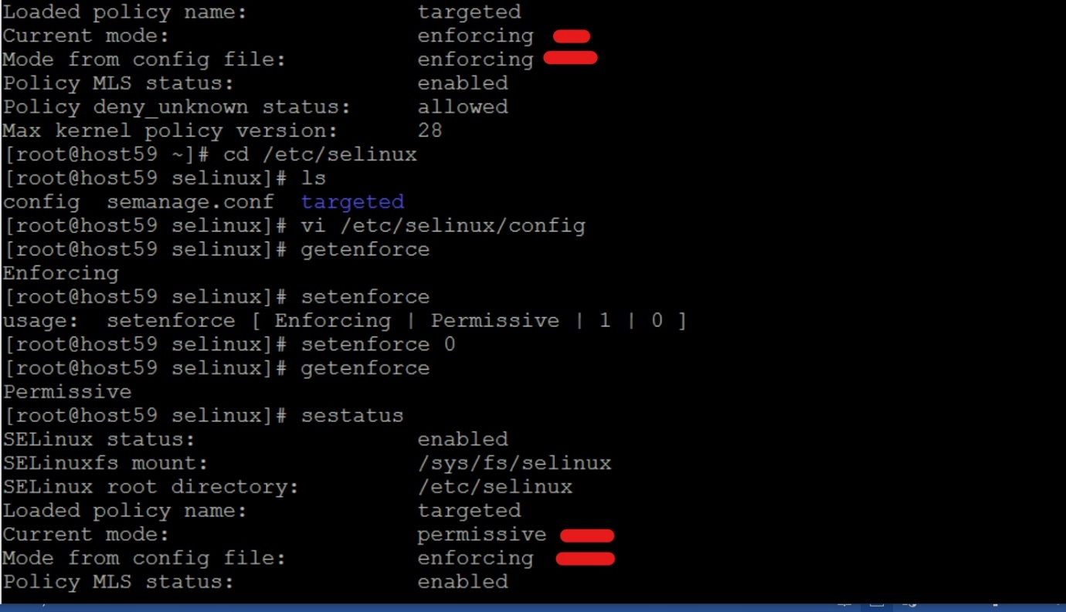

*ls -il*

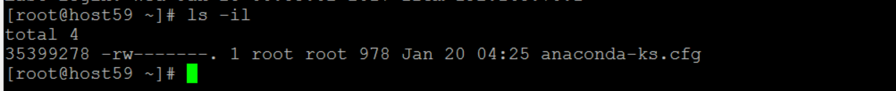

**SSH Communication**

How to connect other linux machine / server:

*ssh-keygen*

*ssh-copy-id -i /root/.ssh/id_rsa.pub 192.168.70.59* ( ip address of other linux)

*ssh 192.169.70.59*

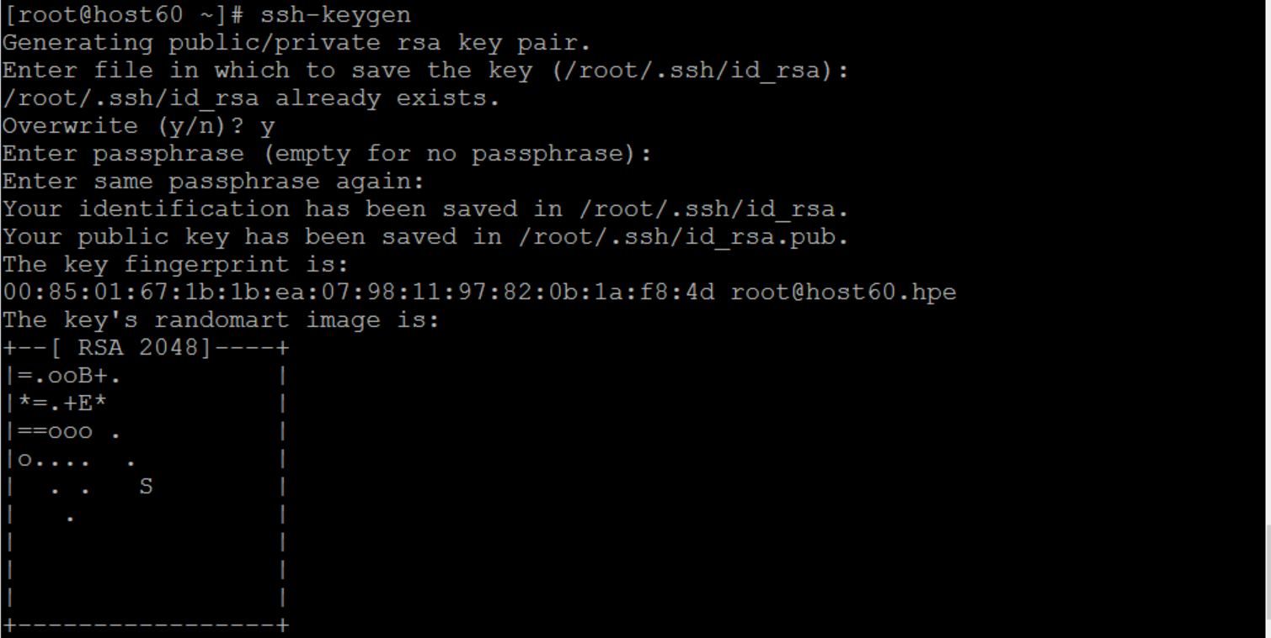

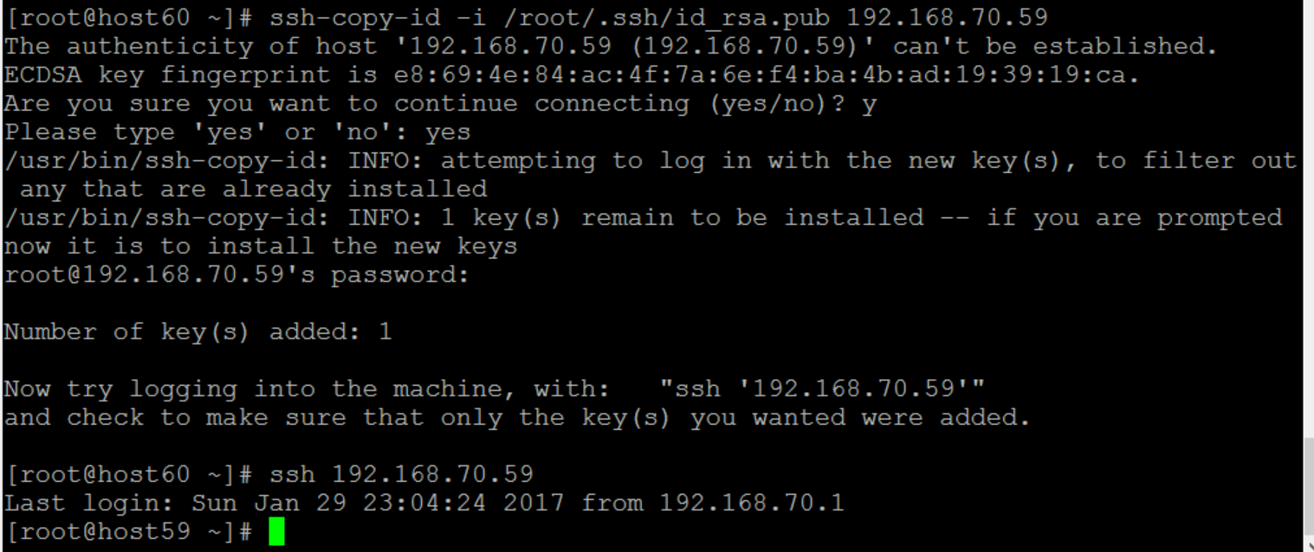

REGULAR EXPRESSION

GREP – Globally Search Regular Expression

* To extract / search the particular word/char in that file
* Command – “ *grep* “

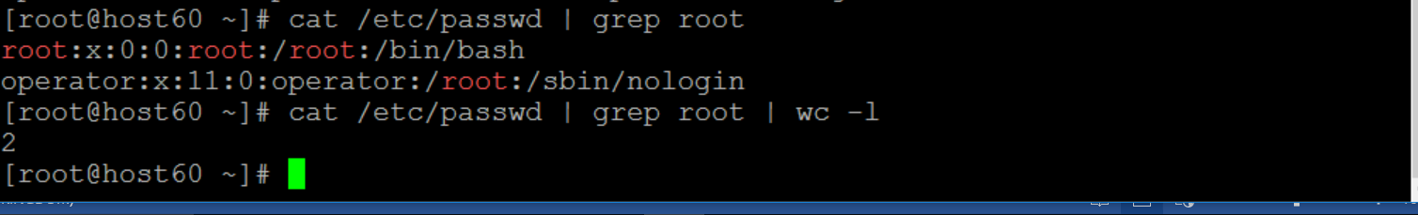

PIPELINE – output of first command will be the input of next command

Symbol – “ | “

I/O Redirection:

Symbol – “ > “ for overwrite

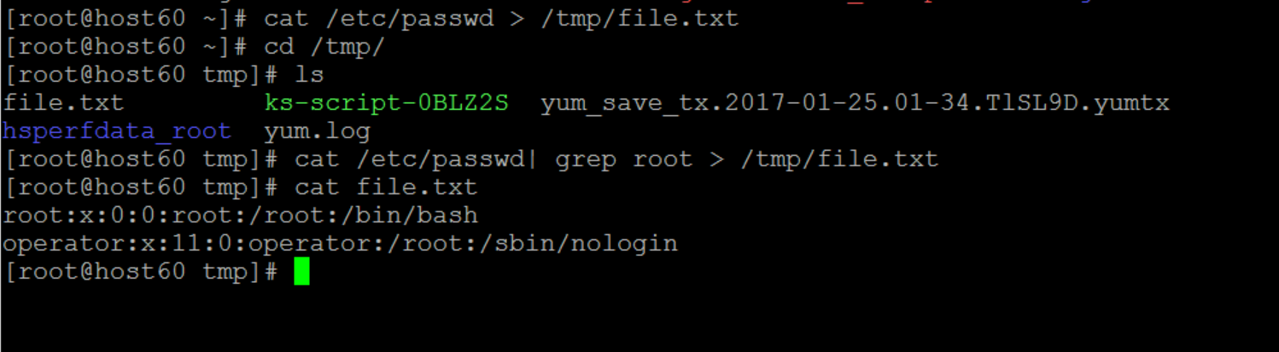

“ >> ” – append

3 kind

* STDOUT – “ >” - overwrite , “>>” – append

*cat /etc/password > /tmp/file.txt*

*cat /etc/passwd >> /tmp/file.txt*

* STDERR – “2>” error will be redirected

*Find / -type f –iname “*.txt” 2> /tmp/adcb.txt*

* STDIN - ????

ps - process

aux – all user execution

ps aux – http is running / not running

*ps aux | grep http | grep 80 >> /dev/null*

**How to change time format to current time(indian)**

NTP – Network Time Protocol

NTP - port number – 123

Check date – it shows EST(European) time

Install NTP packages (Same procedure for chrony packages)

*yum instal ntp*

create “ntp file” in log directory -> *cd /var/log*

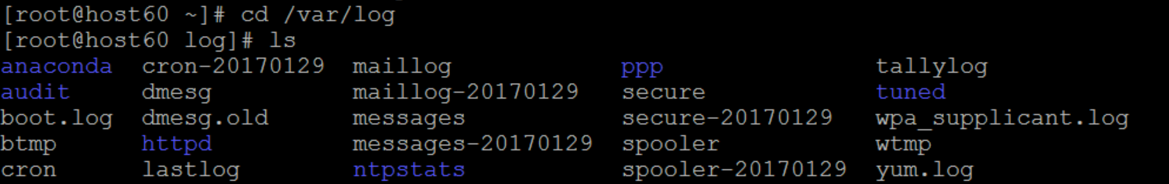

Search in google - Pool.ntp.org -> the correct synchronize time

*vim /etc/ntp.conf -* copy that 3 command from india time standard

and enter - *logfile /var/log/ntp.conf* and save

Start NTP – *service ntpd start*

Check status – *service ntpd status*

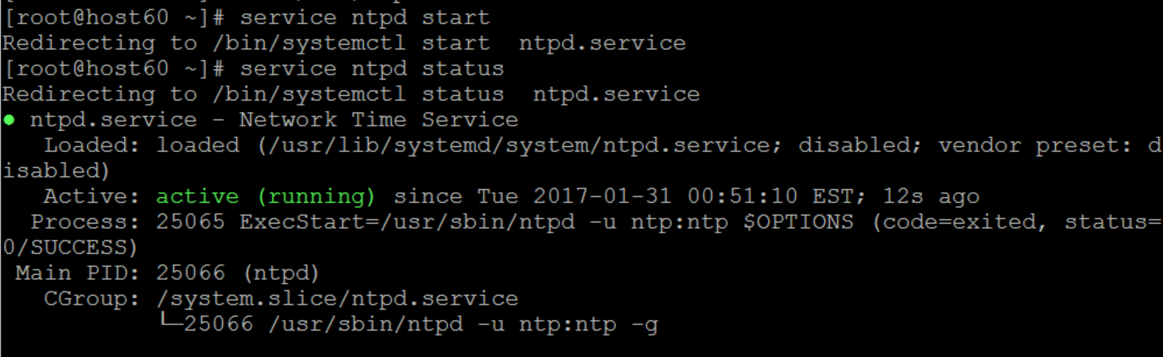

Stop NTP – *service ntpd stop* (or) *systemctl stop ntpd*

Enable / Disable

*systemctl enable ntpd* (or) *chkconfig ntpd on*

**

*system disable ntpd (or) chkconfig ntpd off*

**

After ntpd start , check *cd /var/log –* in there ntp file will be created

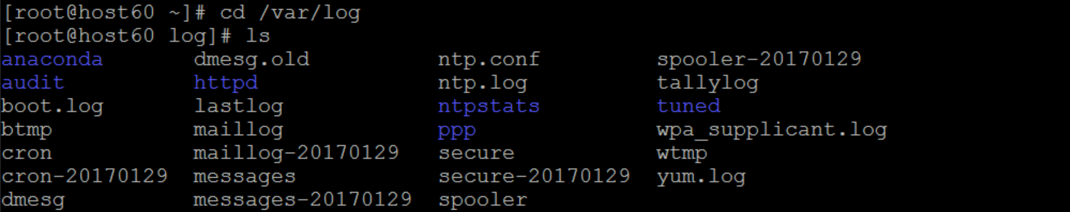

Then stop ntpd – check -> *date* ( time will be changed to indian time )

WINSCP

Step :1

* Open winscp
* Login

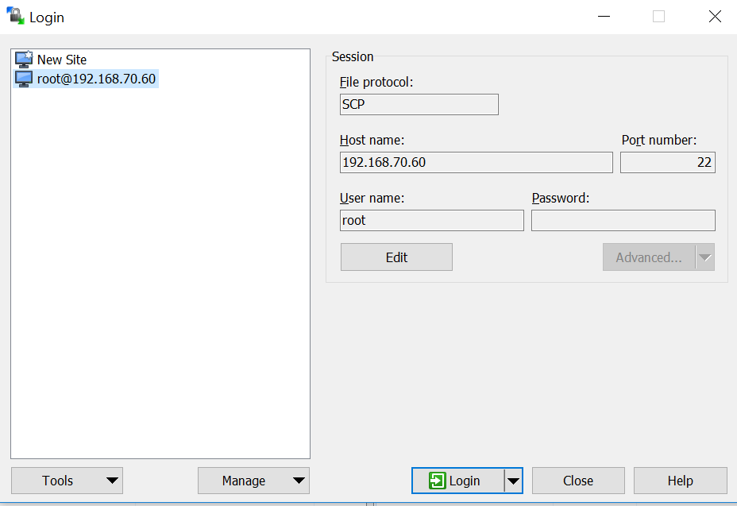

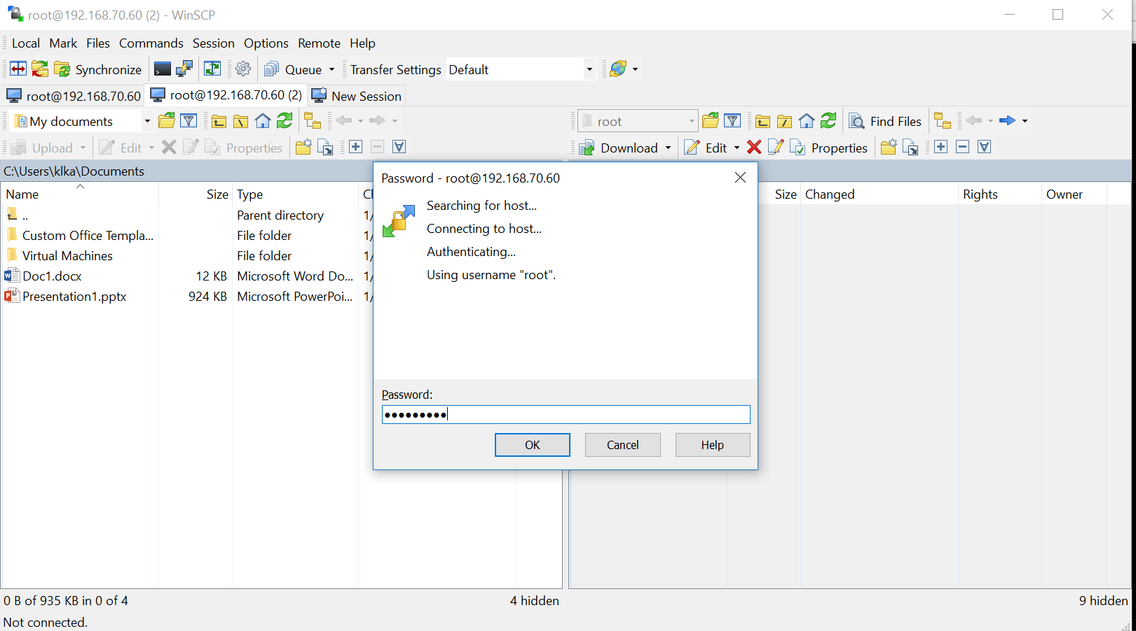

Select file and click -> upload 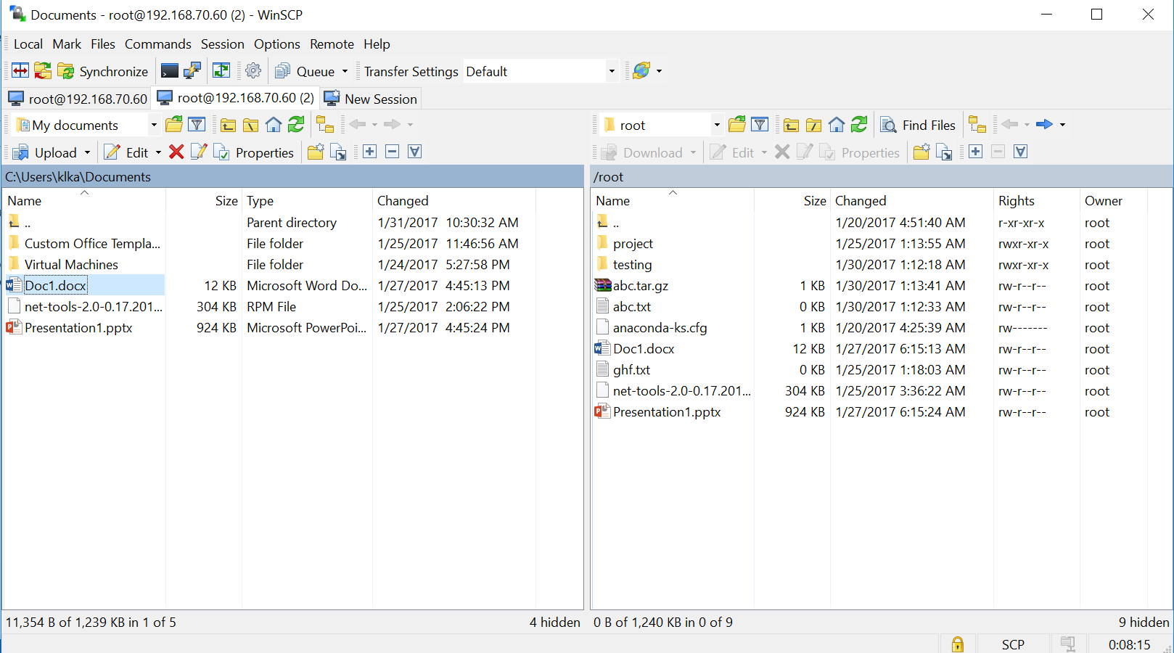

Check in linux with *ls*

